
Objective Questions

1. What is the total no. of tables present in the data?
  - 2

2. What is the total no. of attributes present in the data?
  - 22 + 2 (22 in raw data and 2 in country descriptions)

3. How many categorical columns are there in the data?
  - 12 (RestaurantName, city, Address, Locality, LocalityVerbose, Cuisines, Currency, Has Table Booking, Has Online Delivery, Is Delivery Now, Switch to order menu, Datekey Opening)

4.The data consists of some inconsistent and missing values so ensure that the data used for further analysis is cleaned.
  - Done

5.Using the Lookup functions, fill up the countries in the original data using the country code.
  - Done

6.Create a table to represent the number of restaurants opened in each country.

7.The management wants to look at the number of restaurants opened each year

NO. OF RESTAURANT OPEN EACH YEAR
1120
1100

1080

1060

1040
Total
1020
1000

980
2010
2011
2012
2013
2014
2015
2016
2017
2018

8.What is the total number of restaurants in India in the price range of 4.

388 {=COUNTIFS('Raw Data'!E:E,"India",'Raw Data'!S:S,4)}

9.What is the average number of voters for the restaurants in each country according to the data?

900.00
800.00
700.00
600.00
500.00
400.00
300.00
200.00
100.00
0.00
Total

10.Calculate the average rating for all the restaurants that have price range < 4 and provide online delivery.

3.27 {=AVERAGEIFS('Raw Data'!V:V,'Raw Data'!S:S,"<4",'Raw Data'!P:P,"yes")}

11.Using Conditional formatting highlight the rows of restaurants that are located in the countries or cities that you’ve suggested to the management for opening new restaurants.

Country | Average of Rating | No. of Restaurant in Country | Average of Average_Cost_for_two_person_in _INR
Australia | 3.66 | 24 | 43320
Brazil | 3.85 | 60 | 7375
Canada | 3.58 | 4 | 43320
India | 2.77 | 8652 | 502.2191401
Indonesia | 4.30 | 21 | 1490
New Zealand | 4.26 | 40 | 24495
Philippines | 4.47 | 22 | 3110
Qatar | 4.06 | 20 | 11870
Singapore | 3.58 | 20 | 43320
South Africa | 4.21 | 60 | 2340
Sri Lanka | 3.87 | 20 | 145
Turkey | 4.30 | 34 | 1210
United Arab Emirates | 4.23 | 60 | 11780
United Kingdom | 4.10 | 80 | 53905
United States of America | 4.01 | 425 | 43320

12.Create a new customized price column that consists of the abbreviation/symbol of the currency along with the Average cost for two value.
- Column Y (Raw data in Excel file)

13. How can you create an array formula in Excel or Google Sheets to count the number of restaurants listed that do not offer online delivery, are in the lowest price range, and have an average cost for two people less than or equal to 250 Indian Rupees?

- 1685
{=SUMPRODUCT(('Raw Data'!P:P="No")*('Raw Data'!S:S=1)*('Raw Data'!X:X<=250))}

Subjective Questions

1.Suggest a few countries where the team can open newer restaurants with lesser competition. Which visualization/technique will you use here to justify the suggestions?

SUGGEST COUNTRIES FOR NEW RESTAURANTS
  - Indonesia (21 restaurants, 4.30 rating)
  - Philippines (22 restaurants, 4.47 rating)
  - Qatar (20 restaurants, 4.06 rating)

Recommendations
Country | Average of Rating | No. of Restaurant in Country | Average of Average_Cost_for_two_person_in _INR
Indonesia | 4.30 | 21 | 1490
Philippines | 4.47 | 22 | 3110
Qatar | 4.06 | 20 | 11870
Turkey | 4.30 | 34 | 1210

2.Come up with the names of States and cities in the suggested countries suitable for opening restaurants.

Country | City | Average of Average_Cost_for_two_person_in _INR | Average of Rating
Philippines | Quezon City | 3110 | 4.80
Philippines | Tagaytay City | 3110 | 4.50
Philippines | Makati City | 3110 | 4.65
Indonesia | Tangerang | 1490 | 4.30
Philippines | Pasig City | 3110 | 4.63
Philippines | Mandaluyong City | 3110 | 4.63
Philippines | Taguig City | 3110 | 4.53
Indonesia | Jakarta | 1490 | 4.36
Qatar | Doha | 11870 | 4.06
Based on high ratings and cost feasibility, Quezon City, Makati, and Pasig City in the Philippines are excellent for launching premium cuisine-focused restaurants. In Indonesia, Jakarta and Tangerang show strong ratings with medium costs, making them ideal for high-margin eateries. Doha, Qatar, though costlier, has a diverse palate and potential for upscale or fusion dining concepts. Tagaytay City and Taguig City in the Philippines also offer promising opportunities with solid customer feedback. Overall, urban centers with high food appreciation and stable spending like these are prime for expansion.

3. According to the countries you suggested, what is the current quality regarding ratings for restaurants that are open there?

The Philippines, Turkey, Indonesia and Qatar show the highest restaurant quality. These countries reflect strong customer satisfaction and vibrant dining cultures. Opening a restaurant in these locations offers promising potential for high ratings and success.
Country | Average of Rating
Philippines | 4.47
Turkey | 4.30
Indonesia | 4.30
New Zealand | 4.26
United Arab Emirates | 4.23
South Africa | 4.21
United Kingdom | 4.10
Qatar | 4.06
United States of America | 4.01






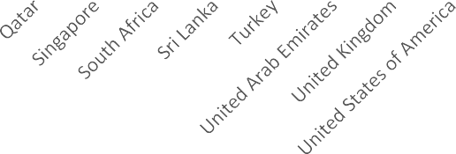

4. What is the current expenditure on food in the suggested countries, so we can keep our financial expenditures under control?
N O O F R E S T A U R A N T I N E A C H C O U N T R Y

According to Data The Average cost of two people in the suggested countries

Country | Average of Average_Cost_for_two_person_in _INR
Qatar | Rs.11870
Philippines | Rs.3110
Indonesia | Rs.1490
Turkey | Rs.1210

5.Come up with the names of restaurants from the recommended states that are our biggest competitors and also those that are rated in the lower brackets, i.e. 1-2 or 2-3.

Target Cities for New Launches
- Santa Rosa, Philippines: Underserved in quality. Focus on modern Filipino or Filipino-Mexican.
- Bogor, Indonesia: Average quality. Bring in a new-age cafe or Japanese fusion.
- Doha, Qatar: High average costs but mid-tier ratings. Offer affordable, modern Indian or Turkish cuisine.
- Ankara, Turkey: High demand for better patisserie or cafe experiences.

Recommendations
- Avoid Oversaturated Zones: Jakarta, Pasig, and Quezon are very competitive.
- Focus on Differentiation: In low-rated areas, bring upscale presentation, tech-enabled dining, or specialty items.
- Cuisine Strategy:
- Philippines: Filipino-Mexican fusion or modern comfort food.
- Indonesia: Japanese, Korean BBQ, or artisan coffee.
- Qatar: Modern Indian street food or Turkish fine dining.
- Turkey: Boutique dessert cafes with traditional-meets-modern ambiance.
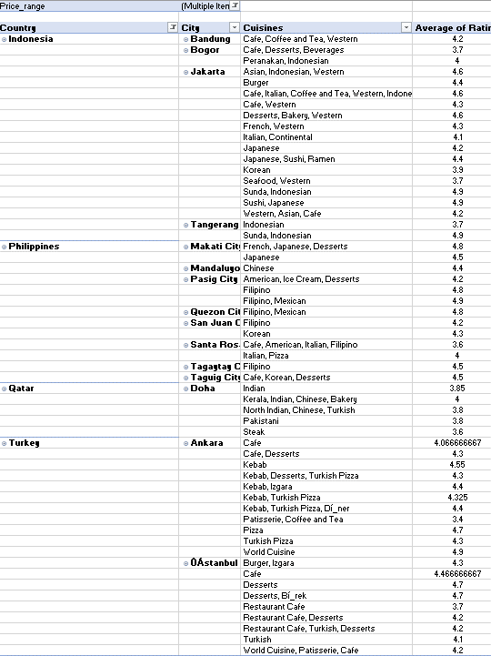

6.Which cuisines should we focus on in the newer restaurants to get better feedback? Does the choice of cuisines affect the restaurant ratings?

- Yes, based on the data, cuisine strongly influences restaurant ratings.
- Cuisines like Sushi, Japanese, European fusion, Filipino-Mexican, and World Cuisine frequently receive ratings above 4.7.
- Simpler or traditional dishes like Bar Food, Pizza, and Desserts also do extremely well across countries.
Recommendations cuisines for New Restaurants
Indonesia:- 1.Sunda, Indonesian, 2. Sushi, Japanese
Philippines:- 1. European, Asian, Indian 2.Japanese, Sushi 3. Japanese, Korean 4. French, Japanese, Desserts
Qatar:- Chinese
Turkey:- 1.Bar Food, Desserts,2. Pizza,3. World Cuisine
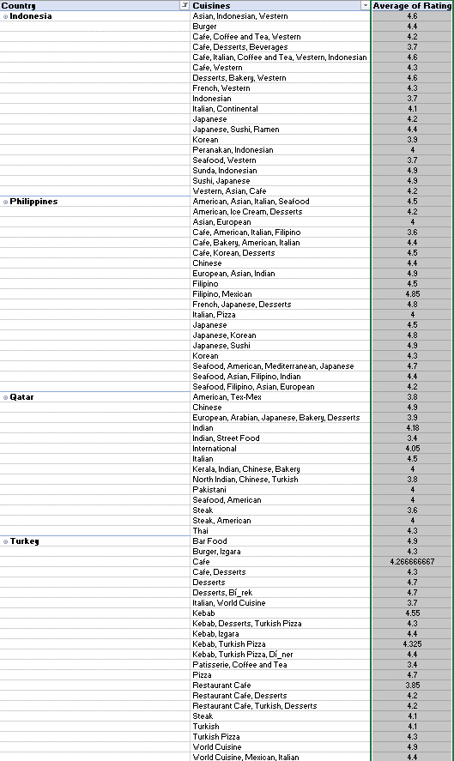

7.According to our current data, should we go for online delivery and table booking? Does that affect the customer’s ratings?

Has Table Booking | Count of RestaurantID | Average of Rating
No | 8393 | 2.809686644
Yes | 1158 | 3.482556131
Has Online  Delivery | Count of RestaurantID | Average of Rating
No | 7100 | 2.754309859
Yes | 2451 | 3.288004896

Table Booking:
- Restaurants with table booking have an average rating of 3.48.
- Those without table booking average only 2.81.
Online Delivery:
- Restaurants with online delivery have an average rating of 3.29.
- Those without online delivery average just 2.75

Recommendations
Yes, it should offer both online delivery and table booking. These services are associated with higher customer ratings, which can improve reputation, retention, and revenue.

8.Should the team keep the rate of cuisines higher? Will that affect the feedback? According to our data are the rates of cuisines and ratings, correlated?

- Should the team keep the rate of cuisines higher
- Answer: It depends on the market. In Qatar, where the average cost for two is 11,870 INR, the rating is 4.06, indicating that high prices do not necessarily result in poor feedback.
- In contrast, Indonesia (Bandung, Bogor, Jakarta, Tangerang) has a much lower cost (1490 INR) but high ratings (up to 4.36), showing that affordable pricing can also yield good feedback.
- The Philippines has a moderate cost (3,110 INR) with consistently high ratings (4.37 - 4.80), indicating that customers accept higher prices if quality is maintained.

- Will higher cuisine rates affect feedback?
- In price-sensitive markets like Indonesia, increasing prices too much may lower ratings, as customers expect affordability.
- In premium markets like Qatar, pricing can remain high, provided the quality and experience match customer expectations.
- Balanced pricing in the Philippines has resulted in high ratings, meaning customers value quality and are willing to pay for it.

- Are cuisine rates and ratings correlated?
- Based on the data, higher cost does not directly lead to higher or lower ratings.
- Qatar (highest cost) has a lower rating (4.06) compared to the Philippines (lower cost but 4.80 in Quezon City).
- Indonesia (lowest cost) still maintains high ratings (~4.3-4.36).

- Conclusion:
- A direct correlation between cost and ratings is not observed.
- The team should focus on value perception rather than just increasing prices.
- Market-specific pricing is key—higher prices can work in premium markets, but affordability is crucial in price-sensitive areas.
Row Labels | Average of Rating | Average of Average_Cost_for_two_person_in _INR
Australia | 3.66 | 43320
Brazil | 3.85 | 7375
Canada | 3.58 | 43320
India | 2.77 | 502
Indonesia | 4.30 | 1490
New Zealand | 4.26 | 24495
Philippines | 4.47 | 3110
Qatar | 4.06 | 11870
Singapore | 3.58 | 43320
South Africa | 4.21 | 2340
Sri Lanka | 3.87 | 145
Turkey | 4.30 | 1210
United Arab Emirates | 4.23 | 11780
United Kingdom | 4.10 | 53905
United States of America | 4.01 | 43320

Conclusion
There is no consistent upward or downward trend showing that higher prices lead to higher ratings. In fact, some of the highest-rated countries have much lower average costs, indicating that affordable pricing does not compromise customer satisfaction.

9.What is the distribution of the number of restaurants of different price ranges in all the countries?

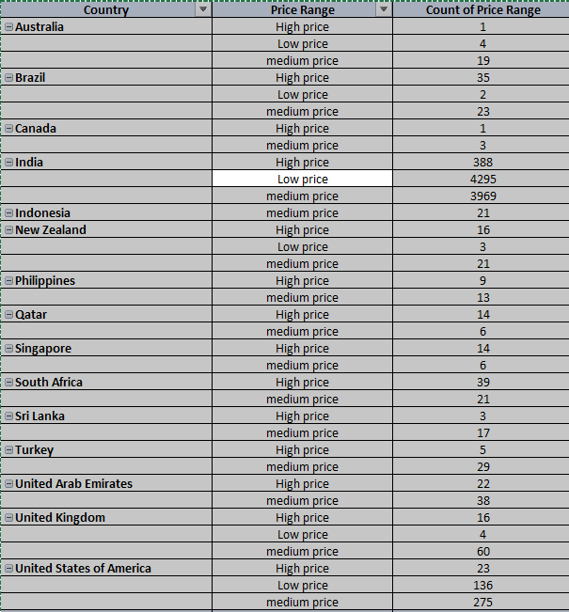

• Low-price restaurants dominate the dataset, especially in India (4295) and the USA (136), showing a strong preference or availability for affordable dining.
• Medium price restaurants with India (3969), USA (275), and UK (60) having the highest counts in this range.
• High-price restaurants are significantly fewer overall, but India (388) and South Africa (39) have notable counts in this category.
• Countries like Indonesia, Canada, and Qatar lean more toward medium price establishments, with limited representation in the high or low categories.
• Some countries such as Turkey, UAE, and Sri Lanka have a relatively balanced distribution between high and medium price restaurants.

10.Explain your approach in brief for suggesting countries/cities in order to open new restaurants, if the objective and subjective questions would have not been given to assist you. [you have to give bullet pointers in order to answer this question]

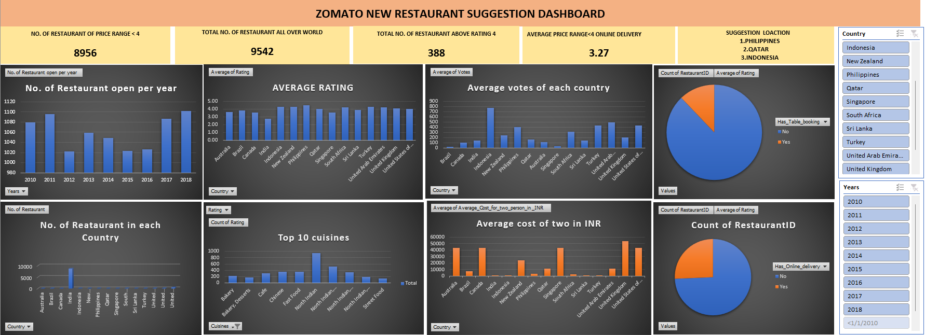

- Identifying Low-Competition Markets
  - We prioritized countries with fewer existing restaurants to minimize direct competition.
  - Example: Indonesia (Tangerang, Jakarta) and Qatar (Doha) have fewer competitors compared to the USA or UK.

- Evaluating Customer Satisfaction (Ratings)
  - Cities with a high average rating (>4.0) indicate a strong food culture and positive customer experience.
  - Example: Quezon City (4.80) and Makati City (4.65) in the Philippines show strong customer approval.

- Assessing Economic Viability
  - GDP per capita was used to estimate spending capacity.
  - Example: Qatar (high GDP per capita) can support premium dining, while Indonesia (low GDP per capita) benefits from affordable options.

- Price Sensitivity Analysis
  - Comparing average cost for two people vs. ratings helped determine if customers prefer budget or premium dining.
  - Example: Indonesia has low-cost dining with high ratings (~4.3), meaning affordability is crucial there.

- Selecting Ideal Cities
  - Cities were filtered based on low competition, high ratings, and economic potential.
  - Final picks:
    - Philippines: Quezon City, Makati City, Pasig City, Taguig City
    - Indonesia: Jakarta, Tangerang
    - Qatar: Doha

